Logbook 5 Template (for offline log preparation)
Name: | Yvette Lee
Week Date: | Part B -Meeting 5 of 8
(The above information is for you to keep track of which week this log is applicable for. This information is not required in the online logbook as the system will find your name, your supervisor’s name, and take the submission date, automatically. You must submit the online log in the relevant week. Logs cannot be backdated to missed weeks.)

Meeting date:  (please note if no meeting is planned this week) | Date and day  23/09/2026 (Wednesday)
Work Undertaken this week:  Not more than 500 words | State the work done from last meeting in Part A (after submission Project Outline) till now?  AI Training Pipeline:  - Cloned the PlantVillage dataset (38 classes, ~54k images) from GitHub to laptop; built a 15-class subset (Tomato x10, Potato x3, Pepper x2)  - Trained MobileNetV3-Small via transfer learning (frozen backbone 10 epochs + fine-tune 5 epochs) - ~90% validation accuracy  - Exported to TFLite with float16 quantisation (~2MB)  - Benchmarked on the Pi 5: 3.5ms, 282 FPS, confirmed CPU inference is sufficient, eliminating the need for coral TPU  - Wrote and deployed ai_inference node ROS2 node which subscribes camera, publishes /plant_health (class+confidence as JSON) and verified end to end  - Full pipeline (training scripts, models, node) committed and pushed to GitHub  Camera/ROS2:  - USB webcam streaming and capture nodes operational in robot_control package; setup.py entry point bugs resolved  Farmer Dashboard Scaffold:  - Built Flask farmer-facing dashboard: results table, summary statistics, and GPS health map (Leaflet/OpenStreetMap) with auto refresh every 5s  - result_logger ROS2 node simulates waypoint scans every 10s (GPS coordinates, classification, confidence) writing to shared result.json  - Verified live sync: simulated scans appear on dashboard within around 15s; diagnosed and resolved a row-count mismatch (browser cache vs Flask polling)  Hardware:  Battery (3S 11.1V 45C 5500mAh), GNSS, IMU, encoders procured; GPIO allocation decided  Software installed on your laptop  Software installed on laptop (Windows 11):  - Python 3.9 with pip  - TensorFlow 2.x (Keras included) — MobileNetV3-Small transfer learning and TFLite float16 conversion  - matplotlib — training/validation accuracy visualisation for the report  - NumPy — inference testing  - Git + GitHub Desktop/CLI — version control, repository synchronised with the Pi workspace  - Hugging Face datasets library — dataset acquisition (fallback to direct GitHub clone used)  - WSL — reserved for Gazebo simulation and RViz visualisation in later phases  All model training and conversion is performed on the laptop; only the compiled plant_health.tflite model and class_names.json are deployed to the Raspberry Pi 5.  Your Github link:  https://github.com/ypuete10-cmd/IMP-Agribot.git
Problems encountered:  (Not more than 500 words | What are the challenges to your project Outline that you have made or going to make? Why?  - Pi Camera Module 2 incompatible with Ubuntu 24.04: the device opens successfully but frame capture always fails (Read success: False), caused by the missing proprietary rpicam image signal processor stack. Solution: switched to a USB webcam with a standard V4L2/UVC interface. Recorded as a platform trade-off in the report.  - tflite-runtime has no Python 3.12 wheels: Ubuntu 24.04 ships Python 3.12, but the standard TFLite runtime only publishes wheels up to 3.11. Solution: deployed Google's successor package ai-edge-litert instead. Also resolved a NumPy 2.x binary clash with the apt-installed OpenCV by pinning numpy==1.26.4.  - Closed-set classifier limitation: with no "unknown" category, the model confidently mislabels non-plant scenes (e.g. 98% Tomato Late blight when pointed at a wall). Mitigations: added a confidence threshold in the inference node and added a background "Other" class trained on 3,450 negative images from unused crops plus 30 real webcam background shots. Retrained to 89.8% validation accuracy.  - Domain gap between training and deployment data: webcam photographs of leaves were misclassified as Other even though laboratory dataset images classify correctly at 89%. Root cause: webcam-style images were represented only in the background class, so the model associated the camera's appearance with "not a plant". Fix in progress: capturing webcam photographs of leaf images for domain adaptation, rebalancing the Other class to ~800 images, then retraining.  - Dataset download reliability: the Hugging Face copy of PlantVillage was unavailable, so acquisition fell back to a direct GitHub clone (~2 GB). This step is now documented as part of the reproducible training pipeline.
Tasks agreed for upcoming week before the next meeting | What are your plan actions/task until the next progress meeting that are agreed with your supervisor  - Complete the domain-adaptation retrain: capture webcam leaf shots on the Pi, sort into class folders, retrain, convert to TFLite, redeploy to the Pi, and verify (non-plant scenes classified as Other/unknown; leaves classified correctly).  - Motor driver first power-up: wire battery through the power distribution board to the L298N drivers, test with wheels off the ground, run a safe PWM ramp, verify motor directions, then keyboard teleop.  - Wire and test the MPU9250 IMU, AHT20, and BMP280 on the shared I2C bus; verify addresses via i2cdetect (0x68, 0x38, 0x76).  - Wire the NEO-8M GNSS on UART (enable_uart=1), verify NMEA output and the /fix topic.  - Push the updated model and dashboard code to GitHub after each milestone.
Figures:  (Upload image files in the online Log Form, but feel free to keep notes here about which images you intend to upload. Use “Figure Caption” information as the filenames, e.g., “Figure 1 – A screenshot of the initial constrained Sketch in CATIA.jpg”) | Bill of materials  Picture of materials  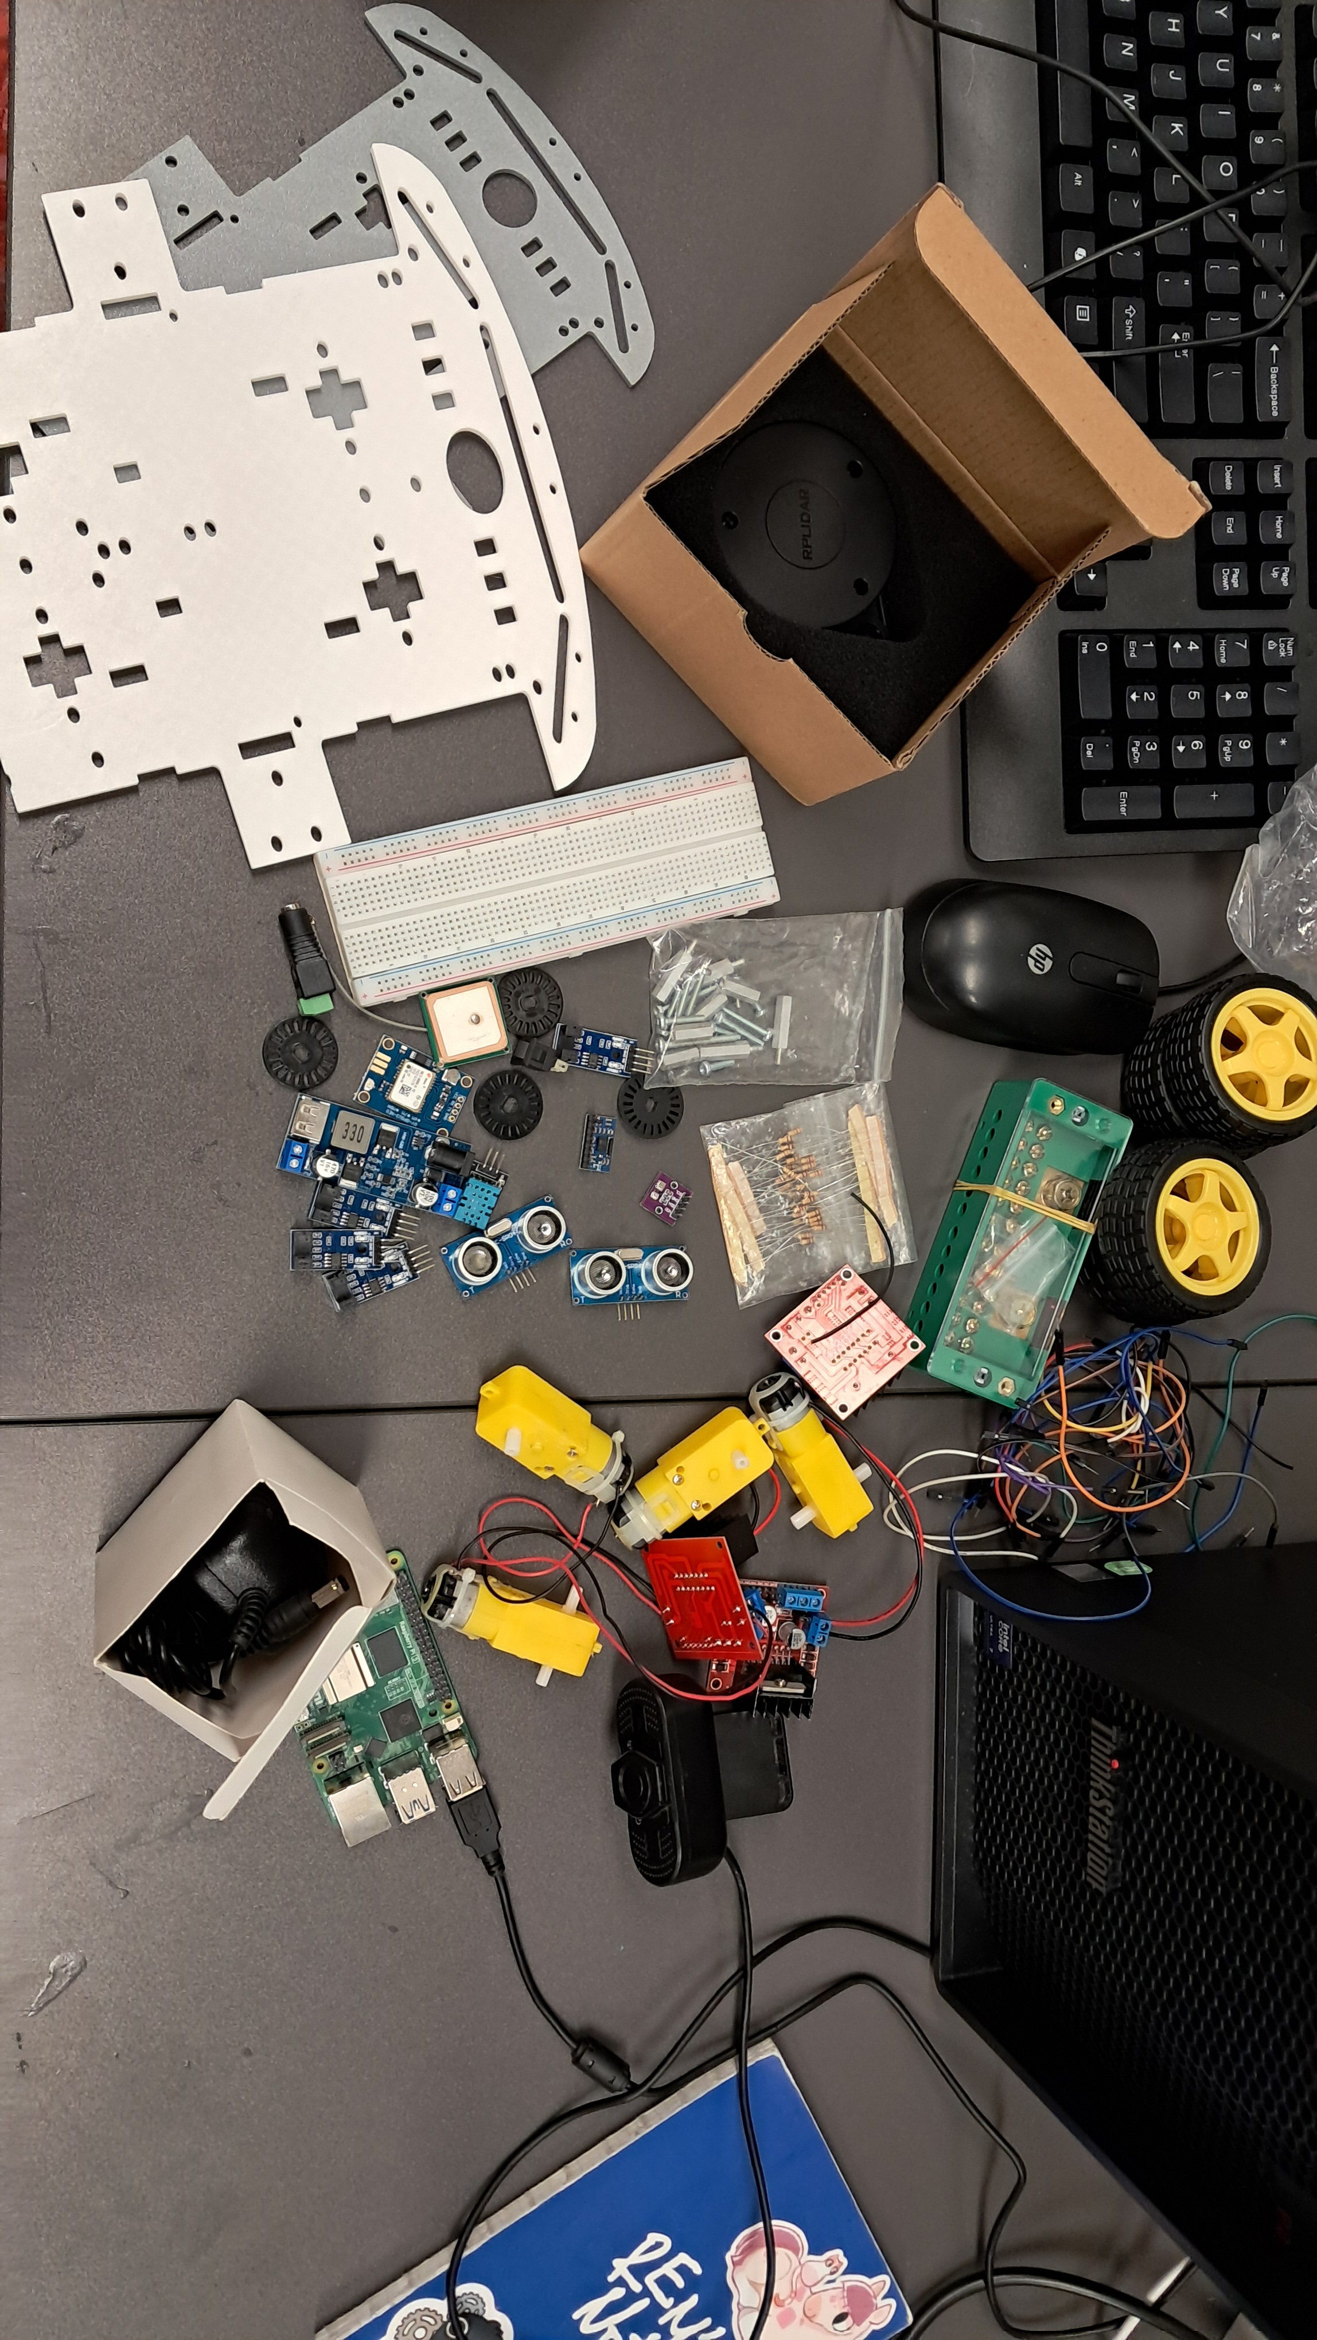
   | Item | Specification | Qty | Source | Purpose
  1 | Raspberry Pi 5 | 8GB RAM, Ubuntu 24.04 + ROS2 Jazzy | 1 | Lab | Main computer
  2 | LiPo Battery | 3S 11.1V, 45C, 5500mAh, XT60 | 1 | Purchased | Main power, ~3.5h runtime
  3 | Power Distribution Board | XT60 input, multi-output | 1 | To buy | Split battery to motors + buck
  4 | DC-DC Buck Converter | 12V → 5V | 1 | To buy/owned | Pi 5 + sensor power
  5 | L298N Motor Driver | Dual H-bridge | 2 | Lab | Drive 4 TT motors
  6 | TT Gear Motors | 6V, with wheels | 4 | Lab | Differential drive
  7 | Wheel Encoders | Hall effect, 20 PPR | 4 | Purchased | Odometry for nav2
  8 | USB Webcam | 1080p, autofocus, UVC | 1 | Purchased | Plant imaging
  9 | GNSS Module | NEO-8M, UART | 1 | Purchased | Waypoint navigation
  10 | IMU | MPU9250, 9-DOF, I2C | 1 | Purchased | Heading + EKF fusion
  11 | Environmental Sensor | AHT20 + BMP280, I2C | 1 | Owned | Temp/humidity/pressure
  12 | Ultrasonic Sensors | HC-SR04 | 2 | Lab | Obstacle avoidance
  13 | LiDAR | RPLIDAR A1 | 1 | Lab | Backup navigation
  14 | Pi Camera Module 2 | 12MP, CSI | 2 | Lab | Removed, Ubuntu 24.04 incompatible
  15 | ADS1115 ADC | I2C, 16-bit | 1 | To buy | Battery voltage monitoring
  16 | Resistors | 30kΩ, 10kΩ, 1kΩ, 2kΩ | ~10 | Lab | Voltage dividers
  17 | Balance Charger | 3S LiPo compatible | 1 | Lab | Safe charging —
  18 | LiPo Safe Bag | Fireproof | 1 | Lab | Charge safety
  19 | Chassis + hardware | Frame, standoffs, jumper wires, breadboard | 1 set | Lab | Mechanical + prototyping

